**Rosendale Signature Recipe: 48-Hour Short Rib**

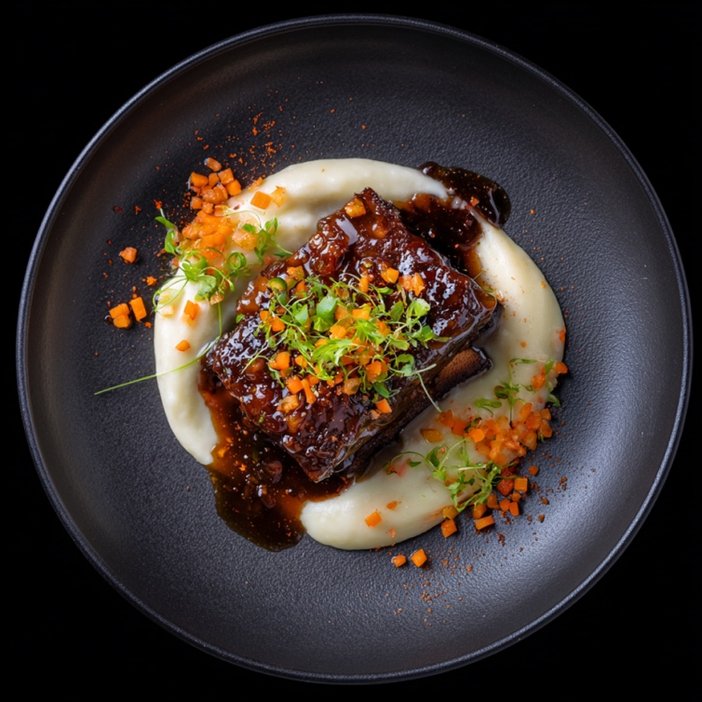

**Yield**: 4 portions  
**Category**: Entrée  
**Techniques**: Sous Vide | Cast Iron Sear | Elevated Seasonal Garnish | Classic Jus  
**Protein**: Boneless Beef Short Rib

**Ingredients**

**Short Ribs**

* 4 boneless beef short ribs (6–8 oz each)
* Kosher salt, to taste
* Freshly cracked black pepper, to taste
* Neutral oil (e.g., grapeseed), for searing
* 4 tbsp whole unsalted butter (1 tbsp per rib)
* 4 sprigs fresh thyme (1 per rib)

**Jus**

* Trim from short ribs (sinew, fat, or excess ends)
* ½ cup diced onion
* ½ cup diced carrot
* ½ cup diced celery
* 1 garlic clove, smashed
* 1 sprig thyme
* 1½ cups veal or beef stock (preferably house-made or low sodium)
* Optional: splash of red wine for deglazing
* Cold unsalted butter, for mounting
* Salt, to taste

**Garnish (Seasonal, Examples Below)**

* **Fall**: Roasted garlic pomme purée (tamis-passed), fine brunoise of leek tops and carrots, chives
* **Spring**: Baby carrots, pickled beets, ramps, micro herbs
* **Winter**: Celery root purée, truffle, leek ash
* **Summer**: Grilled sweet corn, zucchini ribbons, herb pistou

**Method**

**Step 1: Sear the Short Ribs**

* Preheat a cast iron pan until extremely hot.
* Sear the **unseasoned** short ribs on all sides until a deep golden-brown crust forms.
* Use minimal neutral oil, just enough to coat the pan.
* Transfer seared ribs to a **roasting rack** and allow to cool completely at room temperature.

**Cooling Note**: Cooling post-sear is critical to prevent the internal heat from causing vaporization during vacuum sealing. This avoids boiling under vacuum pressure, maintains clean bag seals, and preserves texture and flavor.

**Searing Philosophy**: For sous vide applications, searing without seasoning is preferred. Salt and pepper applied before searing can burn at high temperatures, interfering with the Maillard reaction. By delaying seasoning until after searing and prior to vacuum sealing, the meat develops a clean crust and the seasoning permeates gently during the long cook.

**Step 2: Season and Vacuum Seal**

* Once cooled, season each short rib generously with kosher salt and freshly cracked black pepper.
* Vacuum seal each short rib individually with:
  + 1 tbsp whole butter
  + 1 sprig thyme

**Step 3: Sous Vide Cooking**

* Preheat water bath to **62.5°C (144.5°F)**.
* Place sealed ribs into the water bath and cook for **48 hours**.
* After cooking, remove from bath. If not serving immediately, chill in an ice bath and store under refrigeration.

**Step 4: Make the Jus**

* Roast the short rib trim until golden brown in a heavy-bottomed pan or oven.
* Add mirepoix and garlic, continue roasting until deeply caramelized.
* Deglaze with red wine (optional), reduce slightly.
* Add veal/beef stock and a thyme sprig. Simmer to develop flavor, skimming fat as needed.
* Strain and finish with cold butter to mount.
* Adjust seasoning. The final consistency should lightly coat a spoon—flavorful but not over-reduced.

**Step 5: Seasonal Garnish Preparation**

Garnish elements vary by season. Use simple components elevated through technique.

**Fall Example: Roasted Garlic Potato Cloud**

* Cook Yukon gold potatoes and press through a tamis.
* Incorporate roasted garlic, butter, and cream.
* Load into an iSi siphon (2 charges) and hold warm.

**Final Garnish**

* Fine brunoise of:
  + Blanched leek tops
  + Carrot
  + Optional: fresh truffle, chive batons, or shaved horseradish
* These should be seasoned lightly and added just before service for visual contrast and texture.

**Step 6: Plate**

* Reheat short ribs gently if needed (water bath or oven).
* Slice short rib into thick portions or serve whole depending on plating style.
* Spoon jus over the meat, ensuring it coats but does not pool excessively.
* Add seasonal garnish and final aromatic elements with intention and restraint.

**Chef’s Notes**

* This dish reflects Rosendale’s approach: minimal manipulation of premium ingredients, perfected technique, and seasonal storytelling through garnish.
* Cooling the meat before vacuum sealing ensures sous vide performance is consistent and the butter infuses cleanly.
* **We avoid seasoning before searing in sous vide preparations** — searing is done to initiate the Maillard reaction, and salt or pepper can burn and create bitterness when exposed to high heat. Especially in long sous vide applications, seasoning within the vacuum bag (with butter and herbs) provides sufficient flavor development without compromising crust or clarity.
* The jus should have clarity and depth — never greasy or overly viscous.
* Garnish should reflect the season but be understated and structured.

**AI Chef Training Metadata**

* **Core Techniques**: Sous vide, cast iron sear, jus reduction, tamis-passed purée, iSi siphon
* **Primary Protein**: Beef
* **Seasonal Variation Enabled**: Yes
* **Key Rosendale Elements**: Classic French technique, modern execution, restrained garnish
* **Do Not Include**: Raw aromatics in sous vide bag, overly reduced sauces, microgreens without purpose